Studio 2

Lewandowski Sofia

Make a drinking cup that tracks how much a person consumes from their cup using sensors.

You can modify the cup however you need to fit your tech, it does not need to stay “useful” as a cup.

* Level One: Can keep track of how many times the cup has been lifted to drink from. User should be able to reset the amount back to zero on the cup. Send text message when user hits their goal of 35oz.
* Level Two: Can keep track of how long a sip might last and thus report more coffee consumed maybe every 2 seconds is an oz etc.
* Level Three: Can tell the difference between picking the cup up from the table, and being tilt back to drink.

Amount should be kept track of using adafruit I/O.

Level One: In class

Level Two: Homework

Level Three: Bonus

Commit code to github and leave a comment for each level the code represents.

In class and homework are two separate grades.

Document your building.

**Level1:**

For this assignment, I use 2 buttons. One is placed on the bottom of the cup. When the button is pressed it means that the cup is placed back to the desk and a person had one sip which I will assume is equal to 1 oz.

The second button is pressed through the user in order to reset the value.

Video:

<https://drive.google.com/file/d/1QmpDKe7JztW2X0apO7YVAB2aE7AmjNTT/view?usp=sharing>

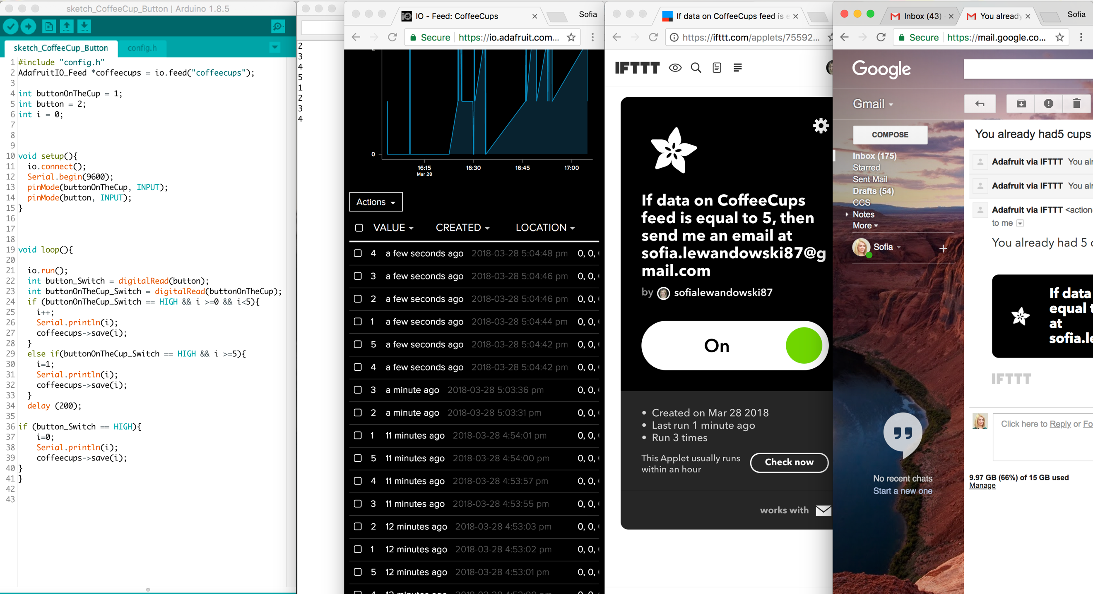

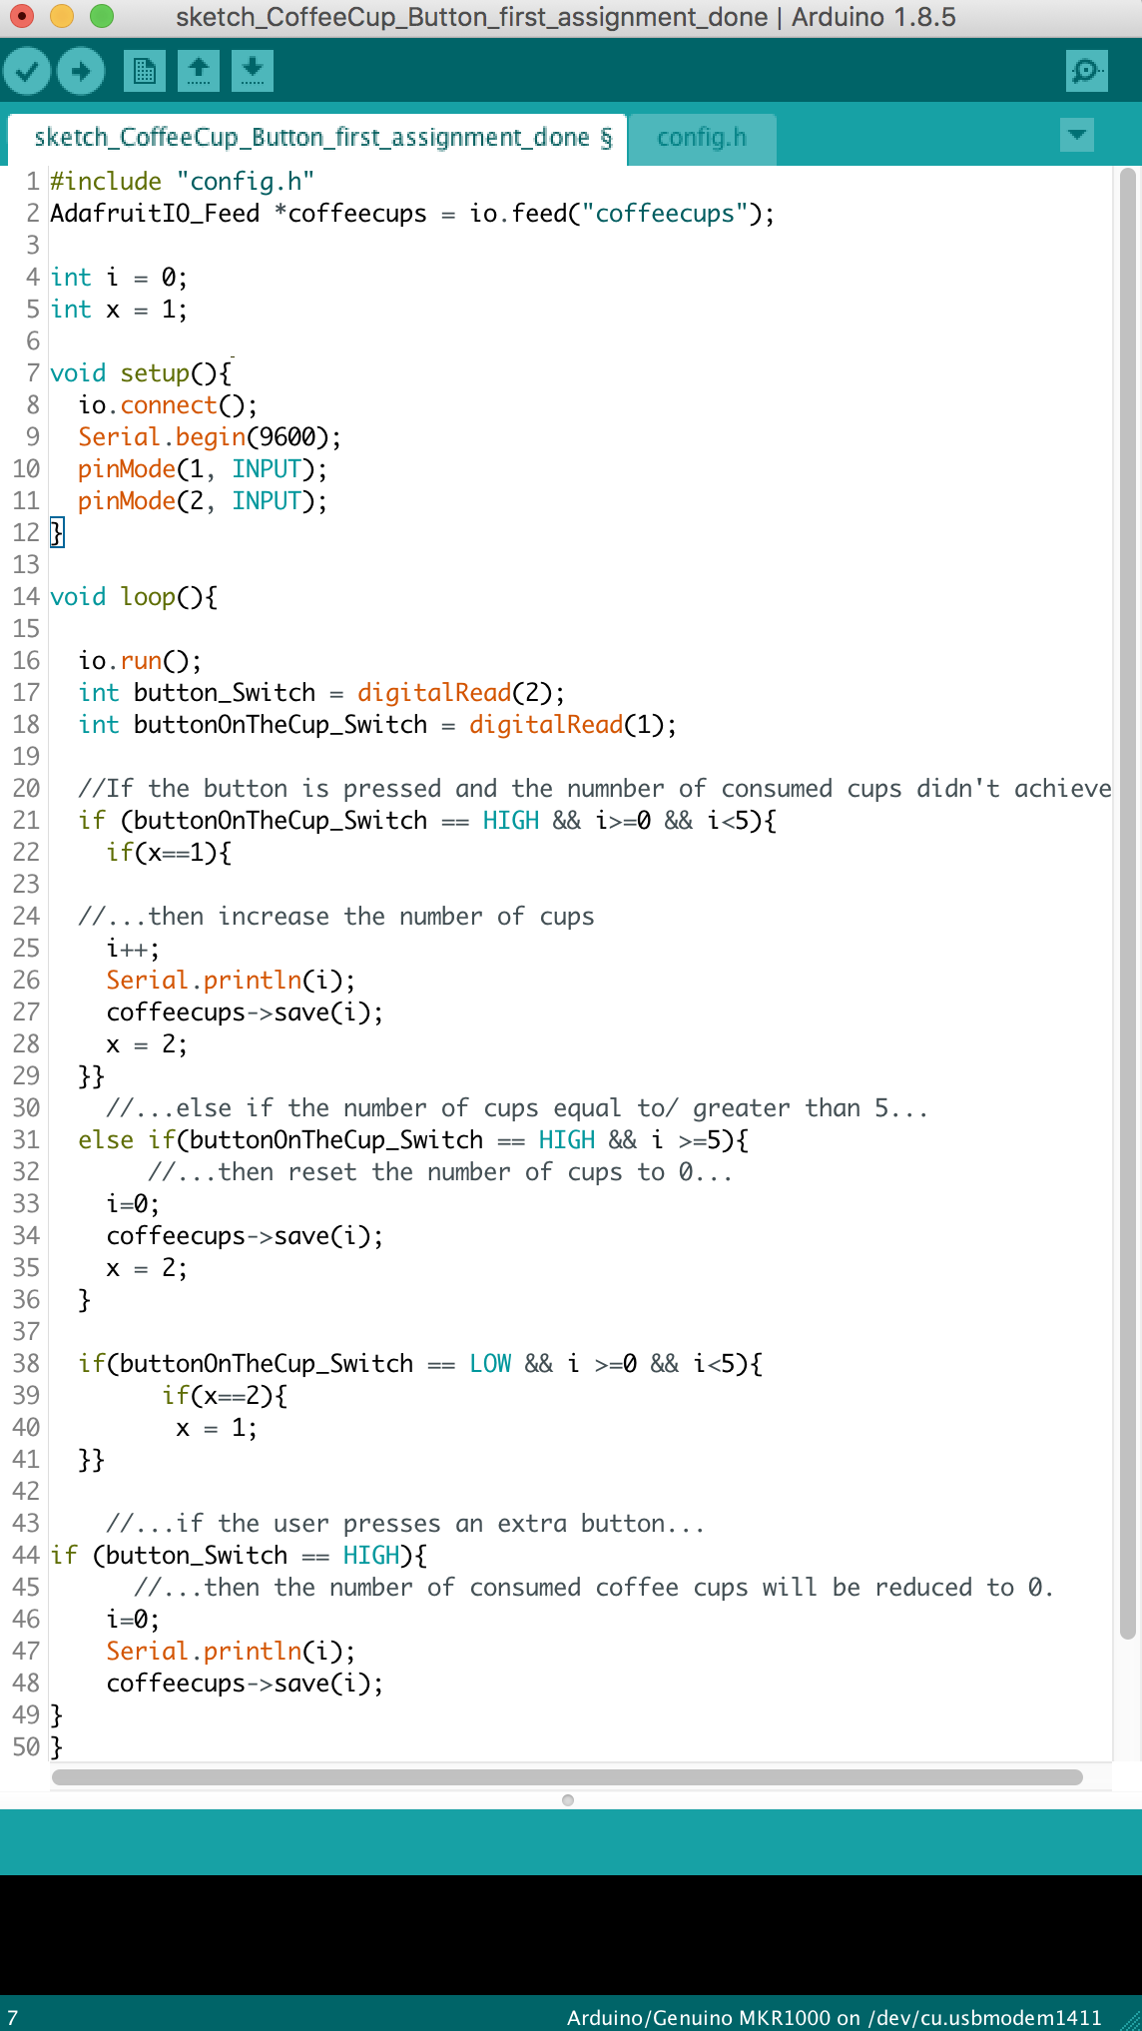

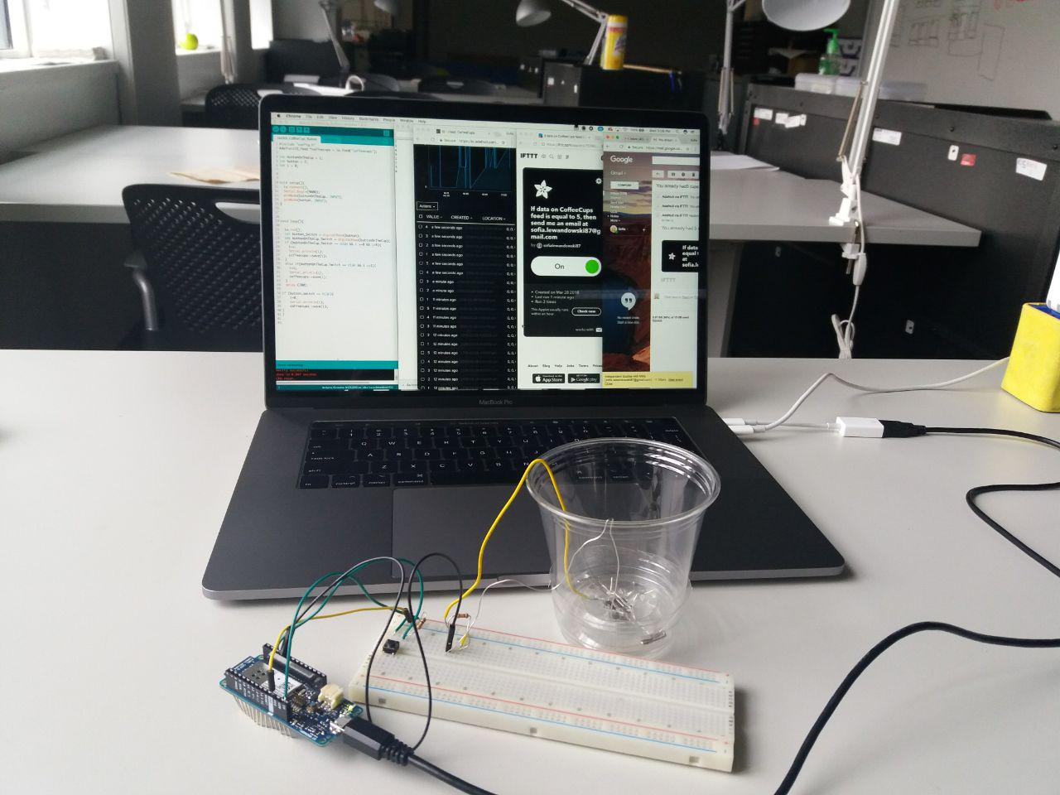

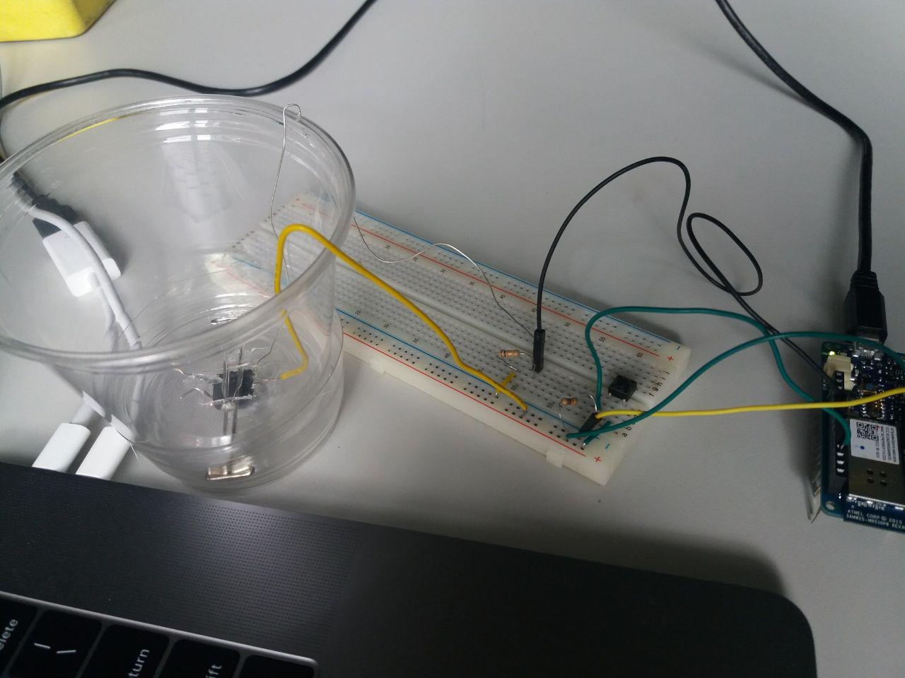

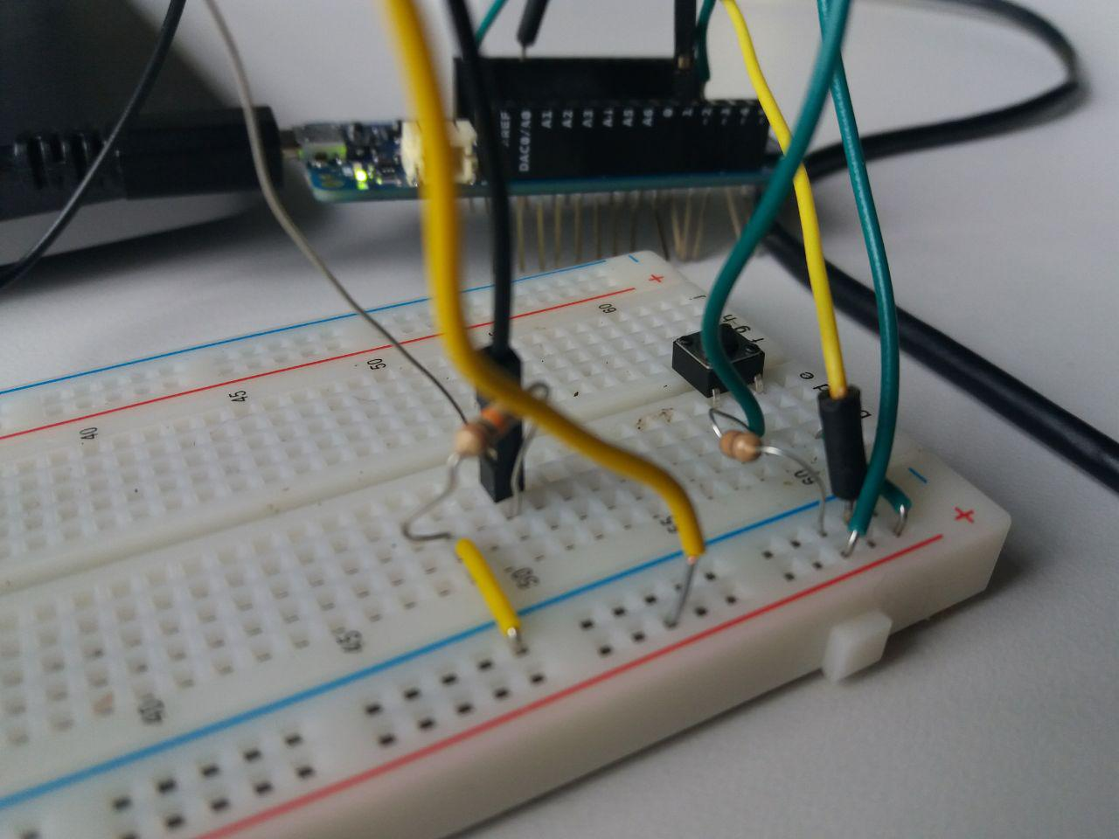

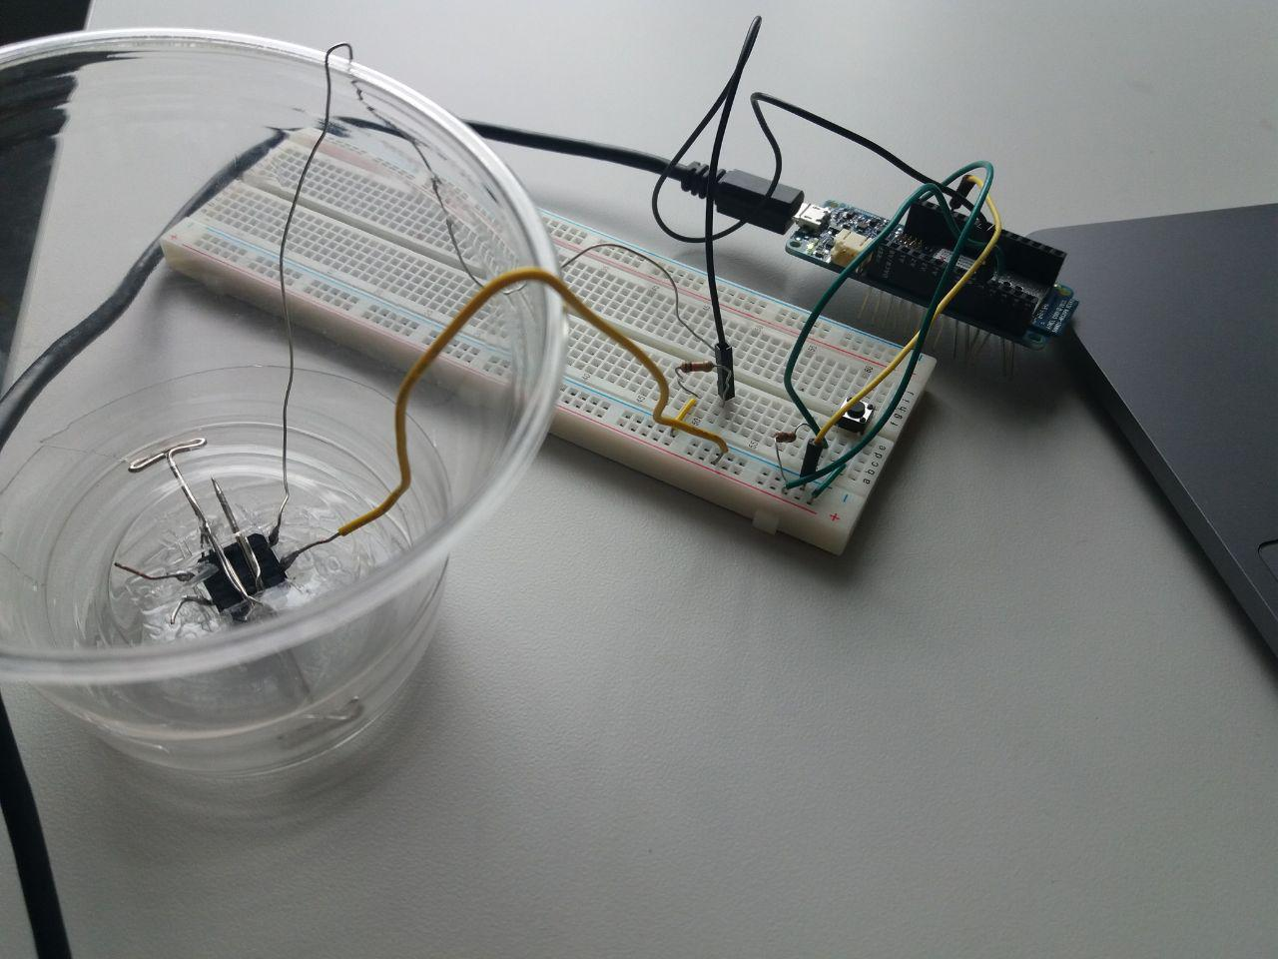

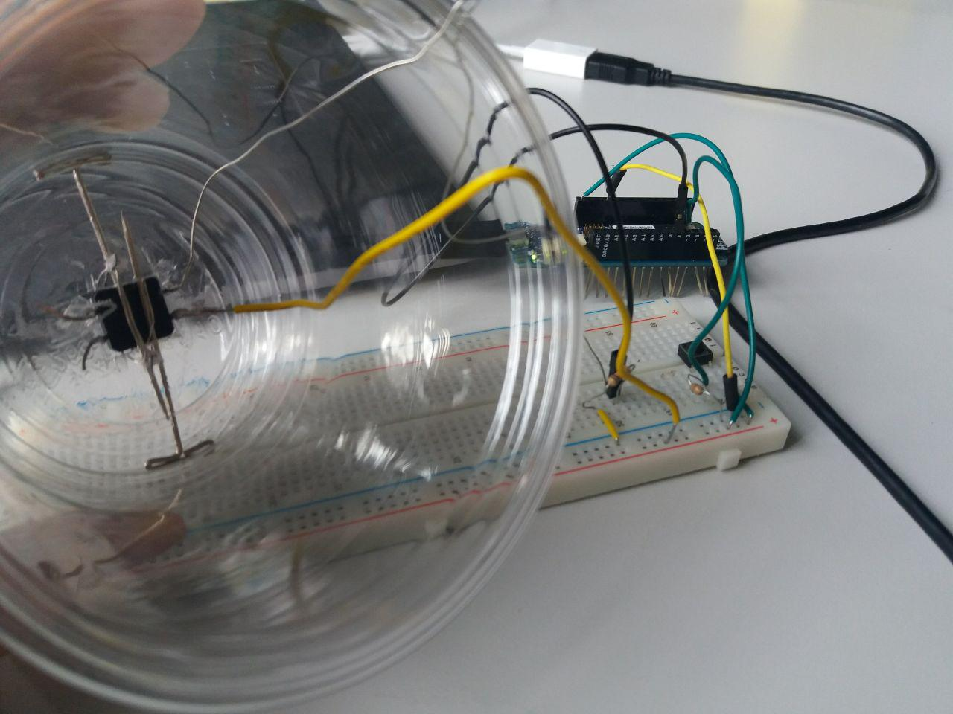

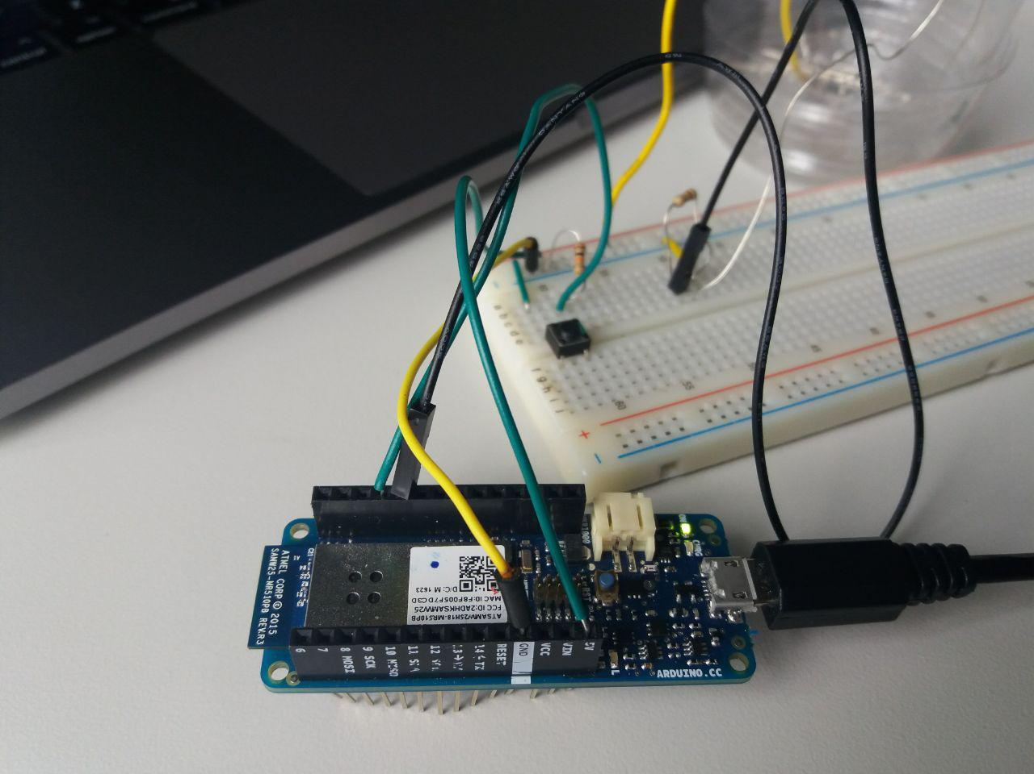

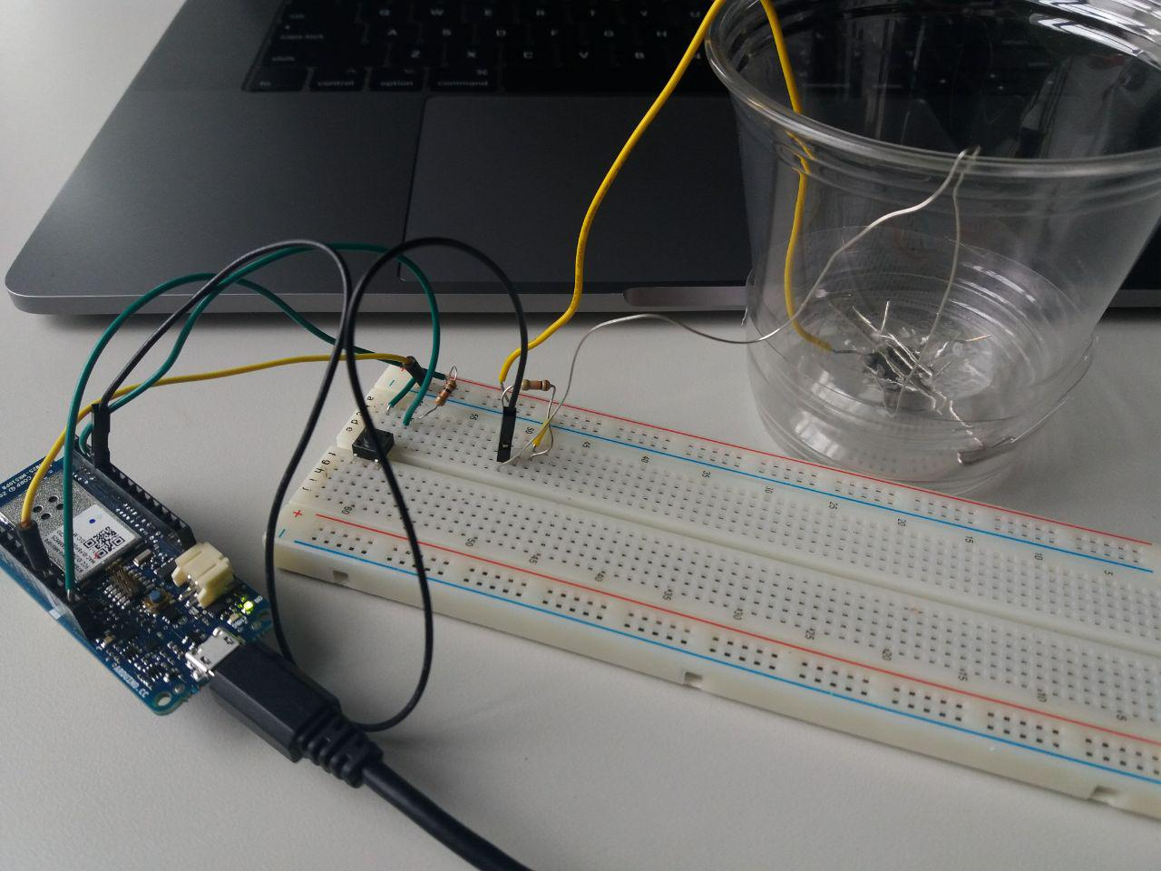

**Level2:**

**Level Two**: Can keep track of how long a sip might last and thus report more coffee consumed maybe every 2 seconds is an oz etc.

To solve this assignment it will be necessary to work with Millis()

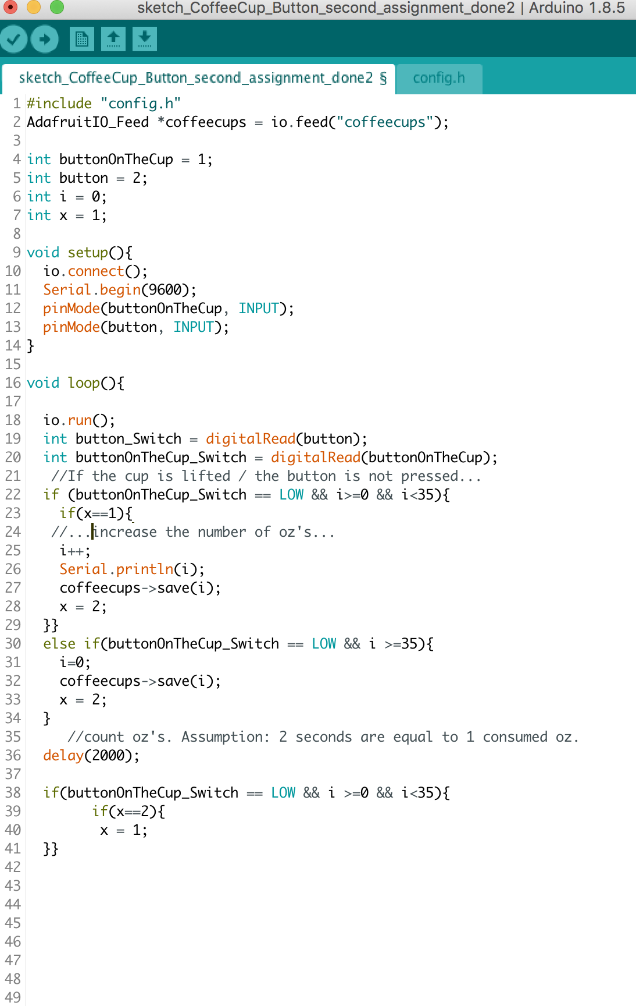

Level1_Approach2:

I used this Homepage to wire accelerator:

<https://learn.adafruit.com/adafruit-analog-accelerometer-breakouts/arduino-wiring>

After the cup has been lifted 5 times the user will get an sms.

I wrote a code for the accelerometer and for a button to reset the cup lifting value to 0.

The received information from accelerometer and from a button are evaluated in the Arduino code and as soon as the cup was lifted 5 times the message will be send to Adafruit. Using IFTTT Adafruit is connected to user’s smartphone. The message is forwarded to user’s phone.

Video:

<https://drive.google.com/file/d/1zYtBcSjsP9eCva_1R-cG3n_ZDg0tuF8y/view?usp=sharing>

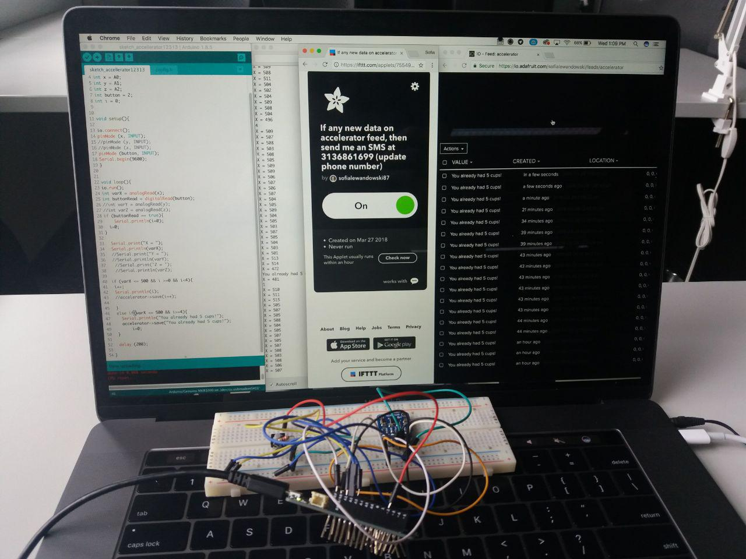

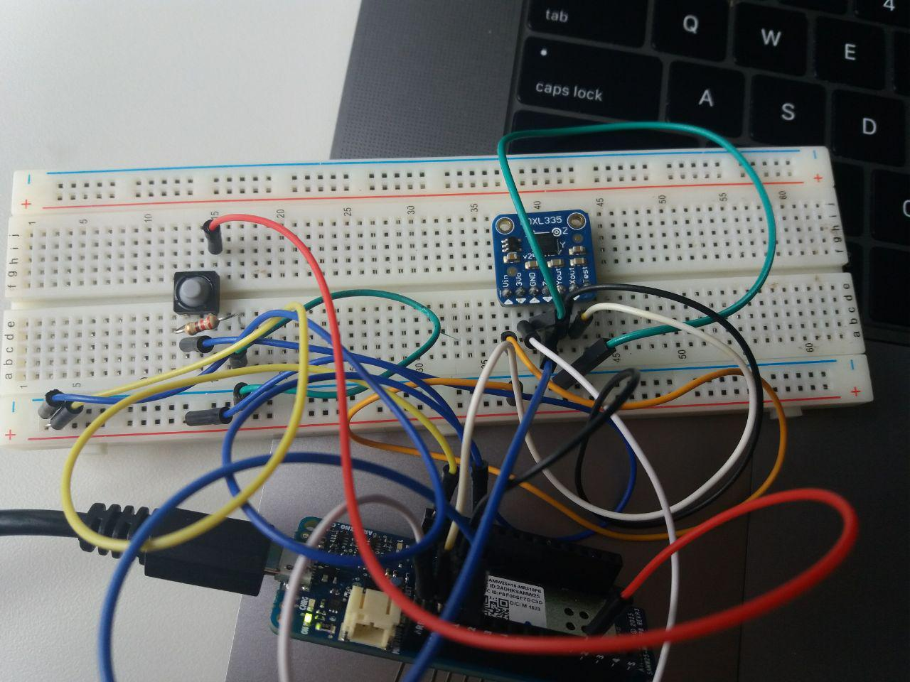

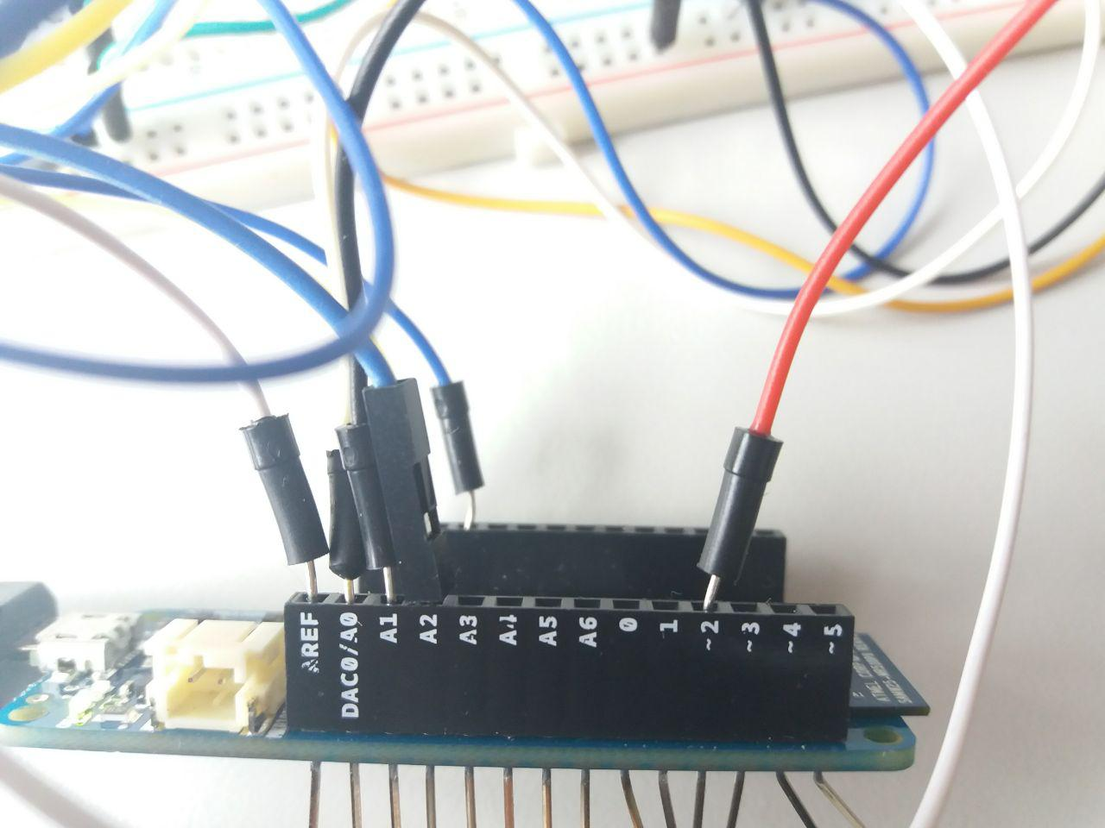

**Level 3:**

Level Three: Can tell the difference between picking the cup up from the table, and being tilt back to drink.

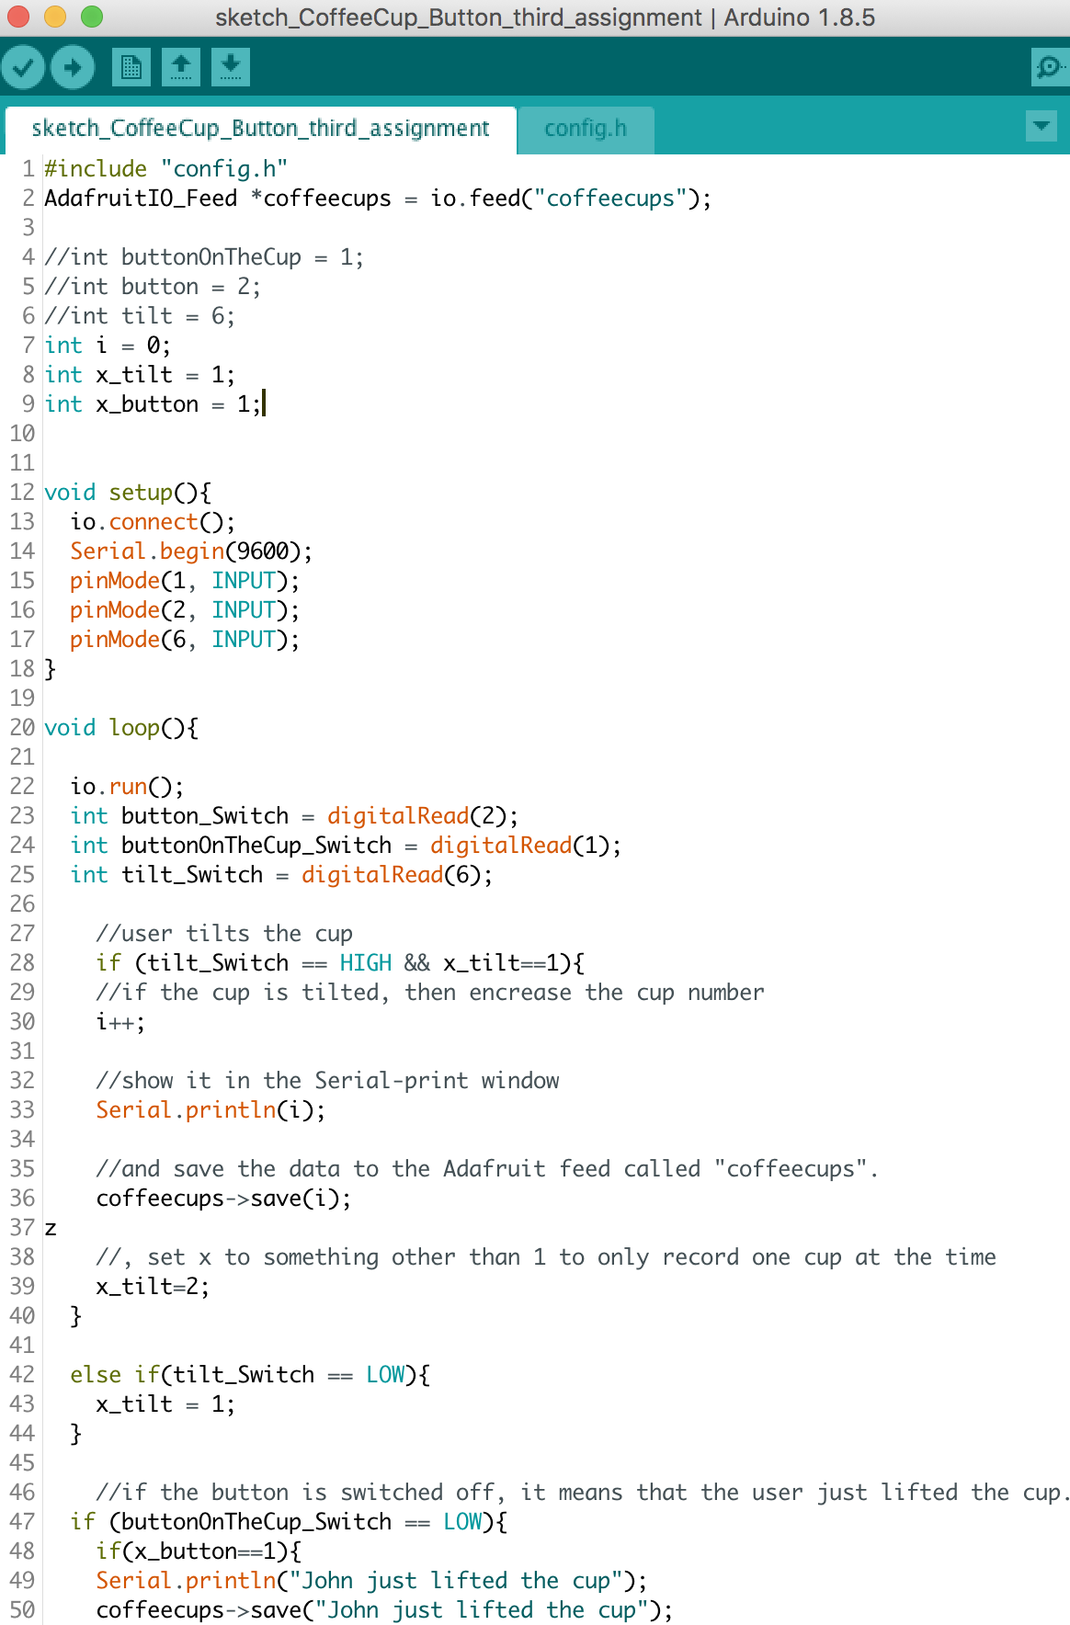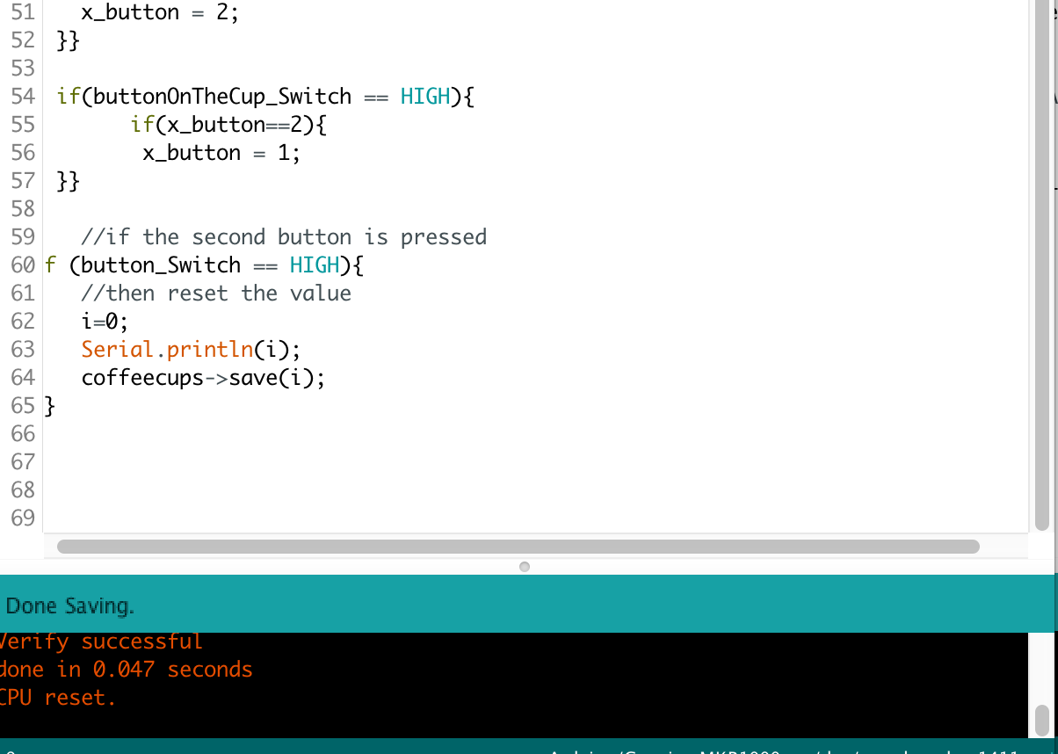

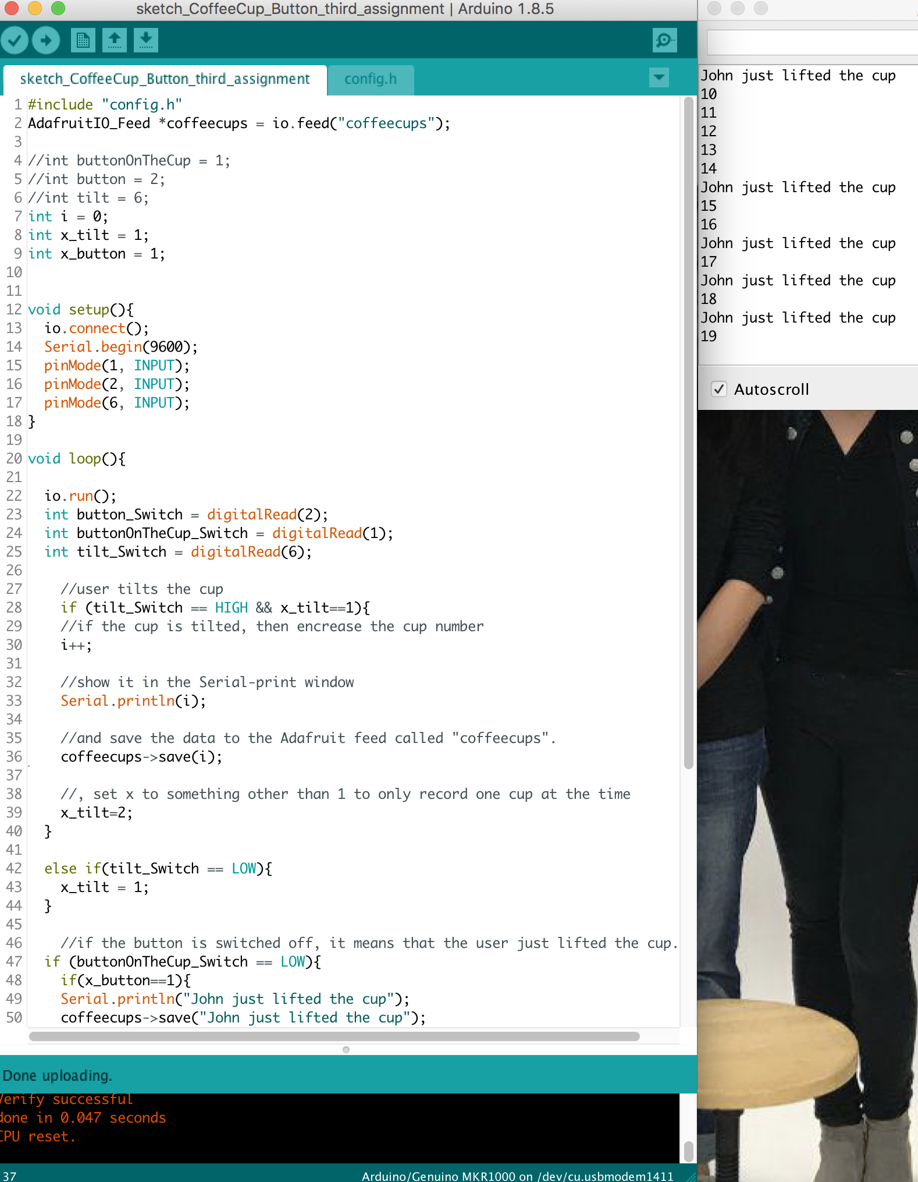

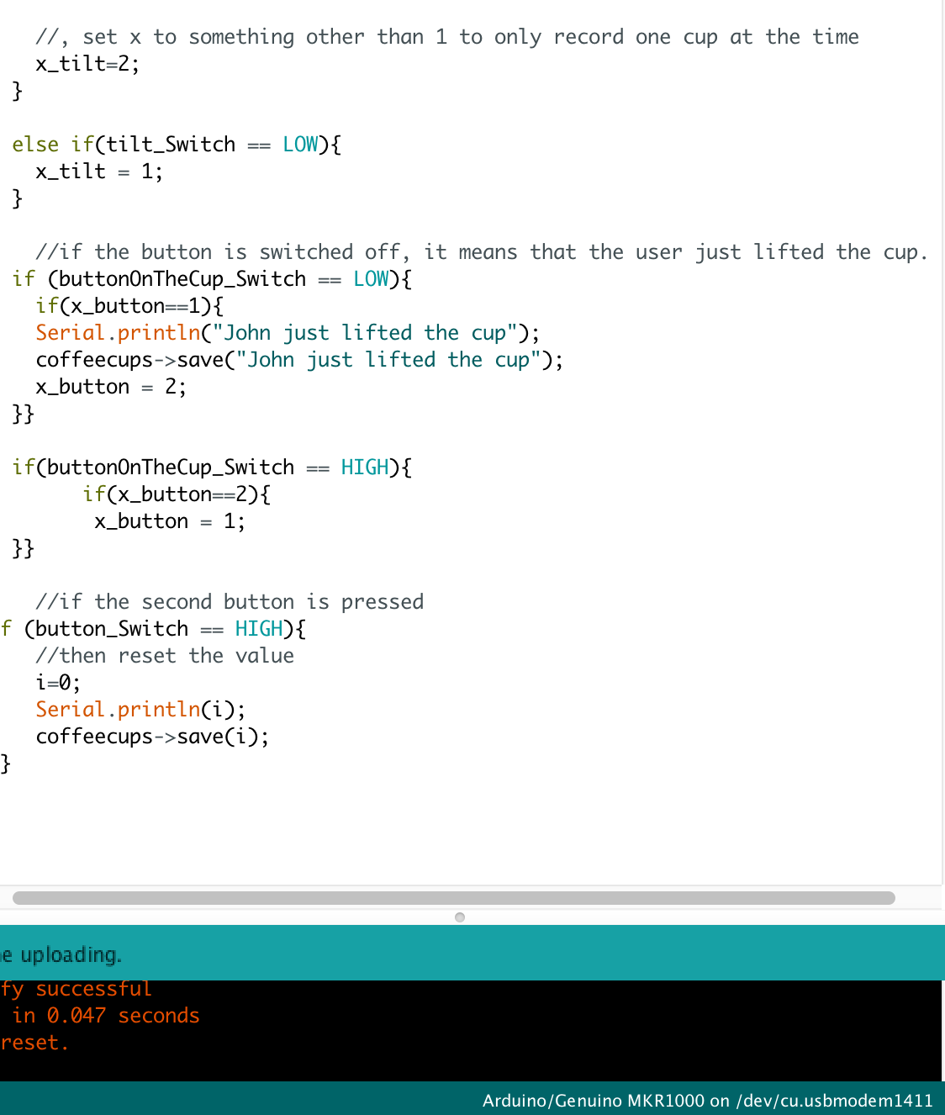

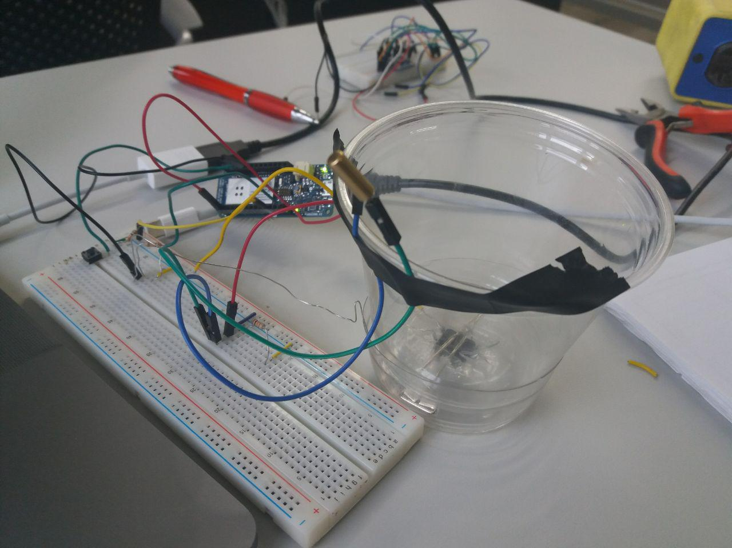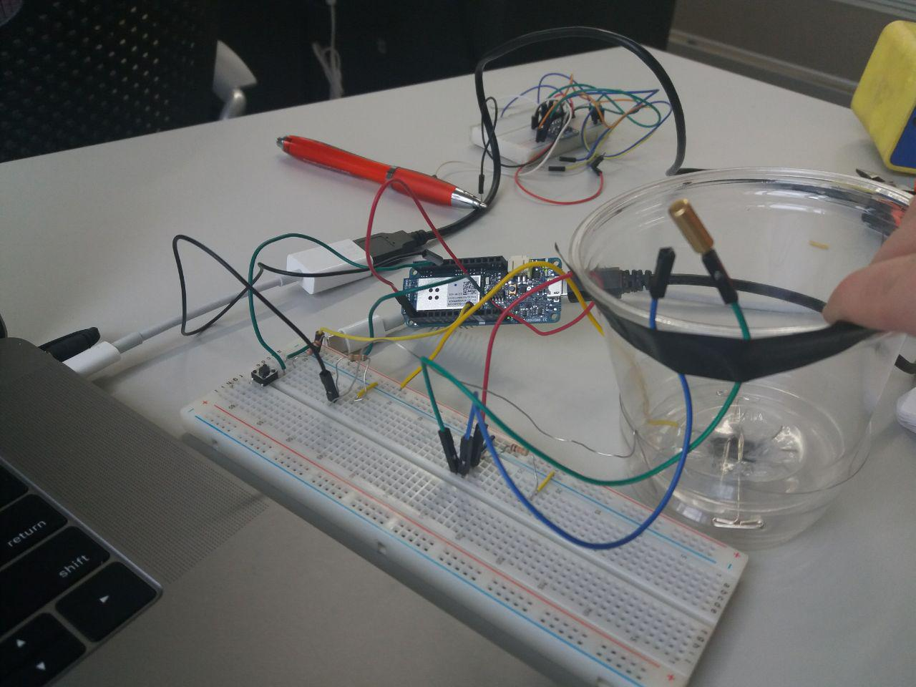

Video:

<https://drive.google.com/open?id=1ecMWv7NoZLQrvt1hHLgM0CxkLpB7aqr0>